**Module 7: Final Research Paper**

John Kolich, 325526

Colorado State University Global

MIS581: Capstone - Business Intelligence and Data Analytics

Dr. Steve Chung

May 7, 2023

**Module 7: Final Research Paper**

**Low Back Pain: The Silent Epidemic**

**Abstract**

This paper investigates the role of various spinal measurements in reported low back pain (LBP). LBP is nearly ubiquitous in developed countries and comes with a wide array of suspected causes and treatments. The standard of care is to move from conservative to invasive treatment, but is nearly always driven by the desires of the patient. Invasive treatment is typically uneventful, but comes with the non-zero risk of increasing pain up to cases where patients do not survive. It is essential to understand all causes and modalities of LBP to keep care in the conservative realm.

Utilizing spinal measurement data and a literature review, the study demonstrates where conservative care can be targeted to reduce reported pain in patient populations. Logistic regression is shown to reliably predict pain using 4 specific spinal measurements. More targeted research in improving these spinal postures is warranted.

**Introduction**

Low back pain (LBP) is one of the most common and debilitating conditions in the modern world. A great deal of money, research, and politics are therefore involved in the treatment and ownership of the condition. Due to the debilitating nature, patients may be more willing to accept reassurances that their pain will get better. Practitioners must all be held accountable to limit risk to patients who are willing to put themselves in unnecessary harm. It is difficult to hold practitioners accountable, as they are all bound by different regulatory bodies and standards of practice. Those dealing with patients or clients suffering from low back pain range from coaches, trainers, psychologists, chiropractors, physical therapists, medical general practitioners, spinal surgeons, researchers, and Eastern healers. Commonality must exist between these professions to create a standard of care that provides patients with the best possible outcomes with the least possible risk.

**Objectives**

Based on the assumptions that LBP is complex in nature, it warrants discussion of whether there is value in medical imaging. The objectives of this project are:

* To determine what outcomes are improved due to known imaging results
* To investigate what outcomes are worsened by the same results
* To suggest a multi-practitioner standard of care that is likely to benefit many cases of LBP
* To examine effectiveness of conservative and non-conservative interventions

**Overview of Study**

LBP is known to respond best to increasingly conservative treatment, but that has never been explicitly defined (Clark et al, 2022, p. 6). Diagnostic and treatment efforts vary widely across practitioners but limited success. Those who view pain as a neurological phenomenon may not consider psychological effects; those who seek functional deficits do not consider structural anomalies; and those who look for tissue damage may not consider social implications. Ultimately, practitioners appear to be stuck in their own dogma on how to properly diagnose and treat LBP. Confoundingly, each professional is correct—at least some of the time. LBP is certainly a multi-faceted condition. Most current evidence supports a bio-psycho-social model of pain, which suggests that a combination of functional, chemical, traumatic, psychological, and social factors all contribute to the severity and frequency of LBP.

The patient instead must be at the forefront of this research. Too many times, professional in-fighting comes at the expense of the health care customer. Unfortunately, if a patient enters into the health care system at the inappropriate level, there is not a financial incentive to refer up or down to more appropriate care, but to perhaps remain over- or under-conservative with treatment. Consistent updates to standards of care are crucial to ensure enforcement of ethical treatment of painful conditions. Secondary orders of effect could be seen in insurance reimbursement, which could lower costs across the board when compared between treatments. The national averages for spinal decompression, fusion, and vertebral augmentation surgeries range from $17,400 to $36,880 (Poslusny, 2021). Surgical procedures are driven by symptoms and objective findings on medical imaging. If imaging were found to be an unreliable source of pain generation, then patients could save large sums of money to resolve their conditions. Hon et al support this finding by concluding direct access to conservative care, as opposed to medical doctors as portal of entry, results in not only cost savings, but improved function within patient demographics (2021).

**Research Questions and Hypotheses**

Research on LBP can be approached in two directions. If a patient describes they are in pain, and medical imaging (typically X-ray or MRI) indicates anatomical defects that support the generation of pain, then surgery may be indicated. The major problem with this outcome is that it is unknown if the abnormal anatomy is actually causing the symptoms in the patient. In tandem with the risk of complications, five-year surgical outcomes demonstrate 79% report “good” (as measured on the 5-point Likert scale) outcomes with 40% reporting increasing pain since the surgery. Of concern, 24% require re-operation, which is observed to decrease positive outcomes. The greatest improvement areas were patients who reported no pain increased by 24% and those reporting constant pain decreased by 43% (Mannion et al, 2010). The cases where pain did not decrease promote questions as to why. Perhaps the anatomical defect was not the cause of pain, complications of surgery, or mistakes and/or sloppy work.

The second direction is the investigation of surgical improvement against conservative methods. LBP has an incidence of 84% worldwide. 85% of these incidences are nonspecific, meaning they have no identified cancer, fracture, herniation, or other lesion. Less than one third of patients seek care, and those that do improve rapidly. Many conservative treatments exist, with varying levels of evidence, in the literature to support a patient through LBP (Salzberg & Manusov, 2013). Due to the increased risk of surgery, it must reliably out-perform conservative treatment to be seen as a viable alternative. An important, and often understated distinction, is that conservative treatment is also not risk-free.

The question asked by this research will focus on both directions by addressing the standard of care:

**In developed countries, is the standard of care for non-specific low back pain adequate to reduce patient risk?**

The question addresses heated discussion in the medical community. Practitioners at all levels want to help patients, and they want to do it in the way they know best. The way patients are treated varies widely even within disciplines. This makes it difficult to suggest a trial of conservative treatment, then if that fails increase invasiveness.

Hypothesis formation addresses the first aspect of LBP—whether anatomical defects are reliable indicators of pain. Each attribute in the Spine data set is a measurement of anatomy that may be relevant to a patient’s experience of pain. Whether these values significantly affect the target variable is determined by eliminating those with p-values above 0.05 in a stepwise fashion. The spine data set will be used to test the following:

H0: Anatomical measurements do not have an effect on patient symptoms: bspinal_measurements = 0

Ha: Anatomical measurements do have an effect on patient symptoms: bspinal_measurements <> 0

The spinal measurement value of b are the individual attributes in the Spine data set. They include pelvic incidence, pelvic tilt, lumbar lordosis angle, sacral slope, pelvic radius, degree spondylolisthesis, pelvic slope, direct tilt, thoracic slope, cervical tilt, sacrum angle, and scoliosis slope. The regression analysis will determine which, if any, of these measures significantly impact reported patient pain.

**Literature Review**

**Medical Imaging**

When a patient presents with LBP a professional should undergo a physical examination of the process. Often this examination involves medical imaging, either X-ray or magnetic resonance imaging (MRI). Providers acting in good faith want to check if any pathology exists “just in case.” However, this act of good faith does not appear to have appropriate results.

The application of imaging to a patient is not only unnecessary as it does not alter the phases of treatment, it may be harmful. Only approximately 5 – 10% of LBP is due to underlying issues, and the remaining 90+% has no obvious underlying cause. The severity of LBP causes patients to seek out a specific cause, which pressures physicians into ordering imaging that is not indicated. Confoundingly, this imaging reveals things like disc degeneration and bone spur formation, which the patient sees, but is not the likely cause of pain. The result is longer healing times and poorer outcomes (Hall et al, 2021).

Conflicting research demonstrates that spondylolysis, disc bulge, degeneration, extrusions, and protrusions are more likely to be found in individuals with LBP. Meta analysis of 280 studies concerning MRI results of individuals under the age of 50 with or without reported LBP show a significant relationship in low back degeneration and reported pain. The study concludes by stating this relationship has not been found to be causal, but may indicate future research as a predictive measure (Brinjikji et al, 2015).

**Patient Risk in Conservative and Invasive Care**

Of primary concern is reducing unnecessary risk to the patient. The literature supports reducing imaging except for cases where severe underlying pathology is expected, which will likely become apparent during a physical evaluation. Unless severe conditions like cancer, fracture, or instability exist, then spinal surgery is elective. Practitioners must make patients aware of the complications of their decisions. Five-year surgical outcomes demonstrate 79% report “good” (as measured on the 5-point Likert scale) outcomes with 40% reporting increasing pain since the surgery. Of concern, 24% require re-operation, which is observed to decrease positive outcomes. The greatest improvement areas were patients who reported no pain increased by 24% and those reporting constant pain decreased by 43% (Mannion et al, 2010). The majority of spinal surgery patients experience positive outcomes, however, for those that did not the risk must be assessed.

Conservative treatment primarily aims to improve patient function and pain through modalities such as massage, exercise, cognitive-behavioral therapy, etc. A common thread among these therapies is a reinforcing idea that the back is capable of being used for activity without increased risk—even if the pain is severe. Multi-practitioner, complex solutions are often effective, but not available to most people (Rainville et al, 2009). It appears that reducing fear avoidance behavior is among the primary goal of anyone dealing with LBP, regardless of profession.

**Research Design**

**Methodology**

This study utilizes a mixed approach. As is often the case in medicine, there is great concern for both qualitative and quantitative measures. In fact, the selected dataset contains all objective measures except for the target variable, which is a patient’s subjective pain. Unless a physician suspects a dangerous underlying condition, then reducing the patient’s subjective complaint is always the goal of treatment.

**Methods**

**T**he Lower Back Pain Symptoms Dataset (hereafter, “Spine”) from Kaggle is utilized (<https://www.kaggle.com/datasets/sammy123/lower-back-pain-symptoms-dataset>). Spine contains 310 observations of 13 attributes. One attribute is the binary class containing either Normal or Abnormal values—this will be the target variable as it indicates reported pain from the patient. The other 12 variables are measured angles from medical imaging which are numeric continuous values.

Investigation of the Spine data set will inform the testing of the hypotheses. A binary target indicating whether the patient reports pain is the target variable. Supervised categorical learning will be used. Exploratory analysis performed with Python using the Pandas library will inform which parts of the data set are useful for analysis. The attributes in the Spine data set will be passed through a regression analysis to determine if the p-values are lower than 0.05. If they are, then that indicates the measurements are statistically significant predictors of reported low back pain, and provide an answer to the hypotheses.

Once the variables have been reduced to those that are significant, it is appropriate to select viable algorithms. In this case, the candidates are logistic regression, random forest, or decision trees as these are all widely used methods in classification and regression (Gangwar & Shaik, 2023). The data is split between training and testing so the best performing algorithm may be selected once they are all run. For this study, the best performing algorithm will be the one that produces the greatest proportion of correctly predicted outcomes on the test data.

**Limitations**

The Spine dataset is limited to testing whether spinal measurements contribute to reported pain. While this is powerful data that is capable of producing results within the scope of this study, it does not offer the necessary holistic context to treat the large problem of LBP. It will offer a piece of a larger puzzle that includes many diverse practitioners.

Spinal anatomy is complex and heavily influenced by various hard and soft tissues. As such, it is difficult to assess causality with the data. For example, a patient may experience LBP which results in a reflexive spasm in the erector spinae musculature. This spasm will increase various spinal measurements such as lumbar lordosis and pelvic angle. Decisions based on the information may suffer from attribution errors which is unlikely to serve the best interests of a patient.

**Ethical Considerations**

Due to the intense nature of LBP there are many ethical considerations to consider. It is understood by practitioners that the condition is an epidemic, but the populous is uncertain of the intervention available to them. Confoundingly, the ethics of research, in this author’s opinion, do not necessarily revolve around patient pain or comfort. Those who have experienced LBP know it is completely disabling when in the acute phase. However, the majority of the time there is no actual danger. The ethics of research must then deal with the aspects of LBP that are dangerous; instability, suspected lesion (cancer or fracture), loss of motor function, and to a lesser degree, radiating symptoms. Because LBP is multifaceted in its causes, patients and researchers must work in tandem to discover helpful modalities. Ong and Hooper find that allowing patients to take part in their plan and share their experiences may help with long term outcomes (2003). It would appear that as long as the patient is not in the immediate danger previously listed, then they only need be informed of expected outcomes and current levels of evidence.

**Findings**

**Exploratory Analysis**

Exploratory analysis is utilized to reveal items of interest. Summary statistics grouped by Class_att (Abnormal = patient in pain, Normal = no pain) demonstrate each attribute’s mean, standard deviation, minimum, and maximum values, seen in Figure 1. Comparison of the mean values between attributes shows that pelvic_incidence, pelvic_tilt, lumbar_lordosis, and degree_spondylolisthesis are 25% or higher in the Abnormal class, and therefore they may be good targets of analysis. Degree_spondylolisthesis is 17 times larger on average in patients with pain. 10 of 12 attributes have higher maximum values and 11 of 12 have lower minimum values in Abnormal patients. The minimum and maximum suggest there may be a range in which pain does not exist, but outside of that range pain becomes likely.

**Figure 1**

*Summary Statistics Grouped by Class_att*

**Class_att=Abnormal**

| **Variable** | **Mean** | **Std Dev** | **Minimum** | **Maximum** | **N** |
| --- | --- | --- | --- | --- | --- |
| pelvic_incidence  pelvic_tilt  lumbar_lordosis  sacral_slope  pelvic_radius  degree_spondylolisthesis  pelvic_slope  direct_tilt  thoracic_slope  cervical_tilt  sacrum_angle  scoliosis_slope | 64.6925617  19.7911113  55.9253700  44.9014504  115.0777125  37.7777051  0.4839788  21.0858748  12.9489129  12.1327370  -13.8266766  25.1469148 | 17.6621293  10.5158713  19.6694714  14.5155597  14.0906047  40.6967405  0.2863193  8.5503655  3.5167621  2.8484010  12.0298242  10.2425131 | 26.1479214  -6.5549483  14.0000000  13.3669307  70.0825749  -10.6758708  0.0032203  7.0270000  7.0378000  7.0306000  -35.2873750  7.0079000 | 129.8340406  49.4318636  125.7423855  121.4295656  163.0710405  418.5430821  0.9988267  36.7439000  19.3240000  16.8210800  6.8684230  44.2338000 | 210  210  210  210  210  210  210  210  210  210  210  210 |

**Class_att=Normal**

| **Variable** | **Mean** | **Std Dev** | **Minimum** | **Maximum** | **N** |
| --- | --- | --- | --- | --- | --- |
| pelvic_incidence  pelvic_tilt  lumbar_lordosis  sacral_slope  pelvic_radius  degree_spondylolisthesis  pelvic_slope  direct_tilt  thoracic_slope  cervical_tilt  sacrum_angle  scoliosis_slope | 51.6852444  12.8214143  43.5426048  38.8638301  123.8908343  2.1865721  0.4498803  21.8163940  13.3072680  11.5145342  -14.5287115  26.6940190 | 12.3681615  6.7785031  12.3613878  9.6240038  9.0142459  6.3074828  0.2847109  8.8464841  3.1429024  2.9559847  12.6752242  10.8520994 | 30.7419381  -5.8459943  19.0710746  17.3869722  100.5011917  -11.0581787  0.0050454  7.3907000  7.4752000  7.0541100  -35.0775370  7.4324000 | 89.8346763  29.8941189  90.5634614  67.1954595  147.8946372  31.1727673  0.9972475  36.6194000  19.2659000  16.6175400  6.9720710  44.3412000 | 100  100  100  100  100  100  100  100  100  100  100  100 |

Distribution analysis is mostly unremarkable except for degree_spondylolisthesis. The histogram in Figure 2 reveals that nearly all Normal patients are binned near 0, where Abnormal patients have heavily right skewed results with an extreme outlier around 400. Spondylolisthesis is a measurement of the proportion of translation of a vertebral body in relation to the inferior body (positive values are anterior, negative values are posterior). Grade V spondylolisthesis indicates a slippage of over 100% and is called a spondyloptosis (Gagnet et al, 2018). While it may be in the realm of reality, a 400% spondylolisthesis is clearly not relevant to the intent of this study, and will therefore be removed from the data.

**Figure 2**

*Histogram of degree_spondylolisthesis*

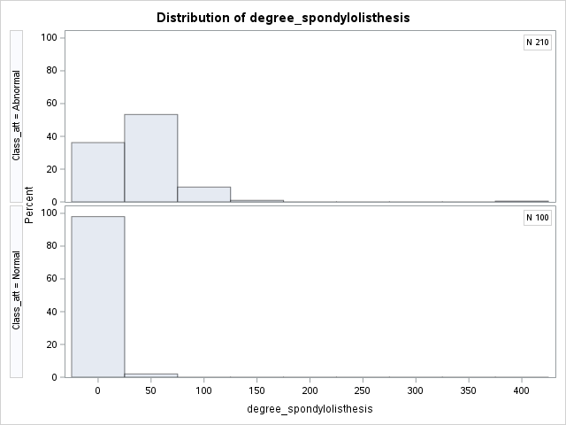

Correlation coefficients are used to determine the relationship of independent variables to one another. This is important to consider because multicollinearity will skew the results of regression study. The assertion of regression analysis is that each explanatory variable is linearly independent. In the case of multicollinearity, this assertion is violated and therefore steps must be taken to reduce the effect. The standard error of regression coefficients will be unreasonably large due if multicollinearity exists (Adeboye et al, 2014, pp. 1, 5). Figure 3 demonstrates strong correlation coefficients between pelvic_incidence, lumbar_lordosis, and sacral_slope.

**Figure 3**

*Correlation Heatmap*

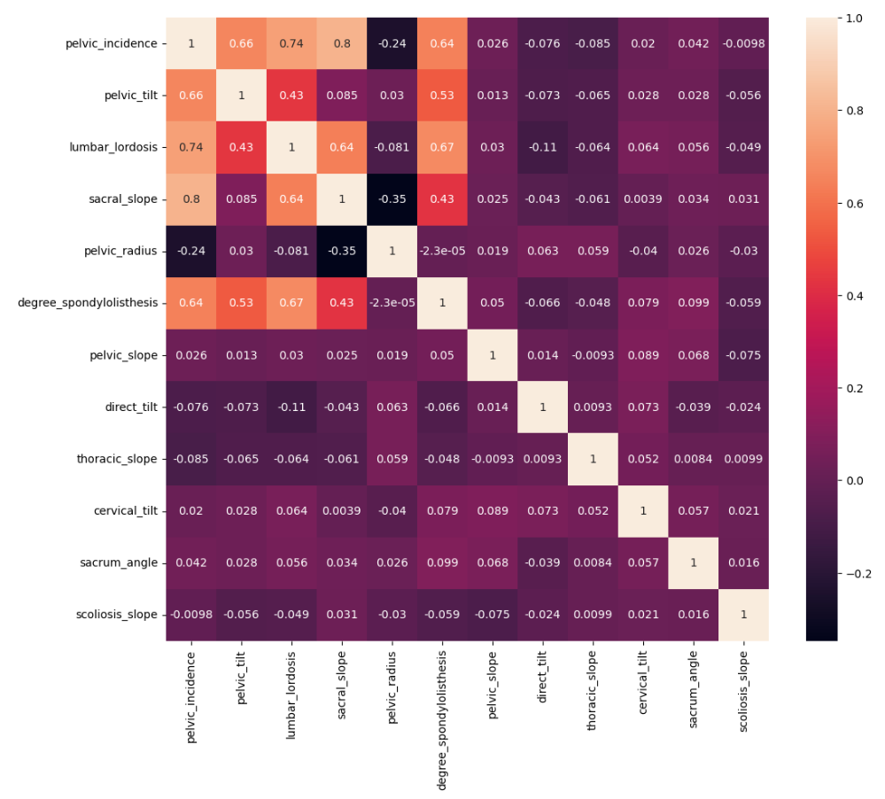

**Variable Selection and Hypothesis Testing**

Initial performance of a logistic regression model indicates several variables with p-values above 0.05, which determines they do not significantly affect the target variable. Stepwise selection is thereafter used to both select variables and test the hypotheses. Figure 4 shows the initial regression where Figure 5 is the remaining significant variables (pelvic_tilt, sacral_slope, pelvic_radius, and degree_spondylolitsthesis). Also, because those variables are shown to have significant impact, the null hypothesis is rejected, and the model is valid. Spinal measurements do have predictable influence on reported pain.

**Figure 4**

*Initial Logistic Regression Model*

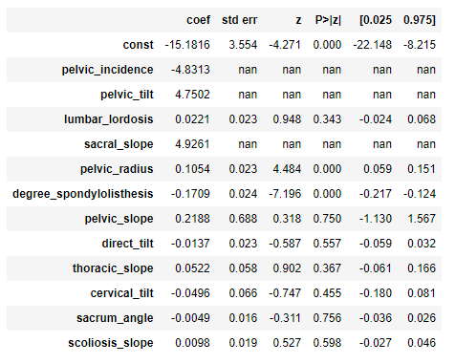

**Figure 5**

*Variable Results After Stepwise Selection*

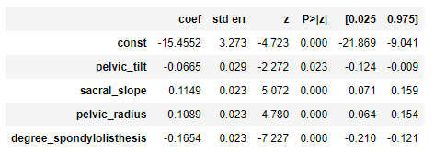

**Model Selection and Performance**

The three models utilized are logistic regression, decision tree classifier, and random forest. Data is split into 80% train and 20% test segments. Abnormal class attribute is the target set at 0.50 sensitivity. The Python library seaborn is utilized to run the three algorithms and export the results seen in Figure 6. Logistic regression and random forest are more accurate than decision tree classifier at 87% compared to 84%. Figure 7 breaks out the errors in confusion matrices. Logistic regression and random forest both correctly identified 52 of 62 abnormal patients. The models had 4 type I (false positive) errors and 6 type II (false negative) errors. In this study, false negatives are more concerning as it is more costly to fail to identify a patient with a pain condition (Banerjee et al, 2009).

**Figure 6**

*Model Performance*

|  |  |  |
| --- | --- | --- |
| Logistic Regression | Decision Tree Classifier | Random Forest |
| 87% | 84% | 87% |

**Figure 7**

*Model Confusion Matrices*

*Logistic Regression/Random Forest Decision Tree Classifier*

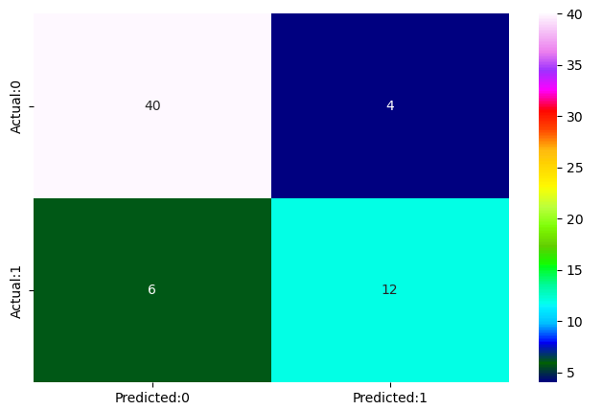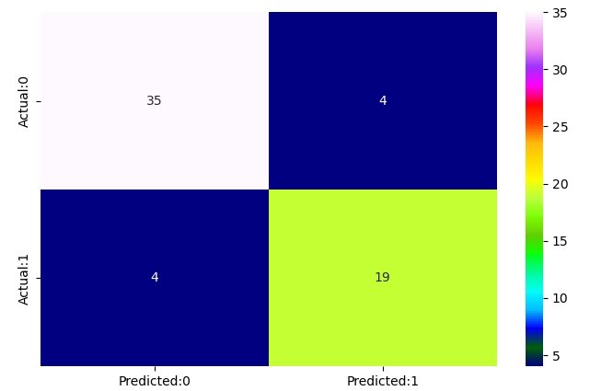

With the validity and accuracy of the model stated, the magnitude of the model can be notated. Using logistic regression, the value estimates can be visualized. Pelvic_tilt and degree_spondylolisthesis appear to increase the likelihood of pain as they increase. Sacral_slope and pelvic_radius decrease the likelihood.

**Figure 8**

*Logistic Regression Estimates*

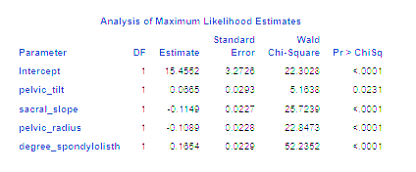

**Conclusion**

LBP is indeed an epidemic of large scale. Established literature indicates that the standard of care should include a multi-disciplinary approach and remain as conservative as possible. Five-year surgical outcomes are typically successful, however come with many risks that may be unnecessary. Most spinal surgery is elective, and therefore patients must remain informed of all of their options.

The results of this study indicate that four spinal measurements are likely to affect experienced pain in patients. Conservative guidance, either through physical training or manual rehabilitation is likely to address these measurements in the desired direction.

**Recommendations**

Recommended use for this information is to develop the fields of athletic training and manual medicine. If certain indicators are known to cause pain, then it is warranted to increase research in areas where conservative medicine can positively affect these indicators (Brekke et al, 2020). Conservative professionals must own the standard of care for LBP by performing well designed studies that show significant postural improvements.

**References:**

Adeboye, N. O., Fagoyinbo, I., & Olatayo, T. (2014). Estimation of the Effect of Multicollinearity on the Standard Error for Regression Coefficients. *IOSR Journal of Mathematics*, *10*(4), 16–20. https://doi.org/10.9790/5728-10411620

Banerjee, A., Chitnis, U. B., Jadhav, S. J., Bhawalkar, J., & Chaudhury, S. (2009). Hypothesis testing, type I and type II errors. *Industrial Psychiatry Journal*, *18*(2), 127. https://doi.org/10.4103/0972-6748.62274

Brekke, A. F., Overgaard, S., Hróbjartsson, A., & Holsgaard-Larsen, A. (2020). Non-surgical interventions for excessive anterior pelvic tilt in symptomatic and non-symptomatic adults: a systematic review. *EFORT Open Reviews*, *5*(1), 37–45. https://doi.org/10.1302/2058-5241.5.190017

Brinjikji, W., Diehn, F. E., Jarvik, J. G., Carr, C., Kallmes, D. F., Murad, M. H., & Luetmer, P. H. (2015). MRI Findings of Disc Degeneration are More Prevalent in Adults with Low Back Pain than in Asymptomatic Controls: A Systematic Review and Meta-Analysis. *American Journal of Neuroradiology*, *36*(12), 2394–2399. https://doi.org/10.3174/ajnr.a4498

Clark, J. D., Bair, M. J., Belitskaya-Lévy, I., Fitsimmons, C., Zehm, L. M., Dougherty, P. E., Giannitrapani, K. F., Groessl, E. J., Higgins, D. M., Murphy, J. L., Riddle, D. L., Huang, G. D., & Shih, M. (2022). Sequential and comparative evaluation of pain treatment effectiveness response (SCEPTER), a pragmatic trial for conservative chronic low back pain treatment. *Contemporary Clinical Trials*, *125*, 107041. https://doi.org/10.1016/j.cct.2022.107041

Gagnet, P., Kern, K., Andrews, K., Elgafy, H., & Ebraheim, N. A. (2018). Spondylolysis and spondylolisthesis: A review of the literature. *Journal of Orthopaedics*, *15*(2), 404–407. https://doi.org/10.1016/j.jor.2018.03.008

Gangwar, A. K., & Shaik, A. G. (2023). k-Nearest neighbour based approach for the protection of distribution network with renewable energy integration. *Electric Power Systems Research*, *220*, 109301. https://doi.org/10.1016/j.epsr.2023.109301

Hall, A. M., Aubrey-Bassler, K., Thorne, B., & Maher, C. G. (2021). Do not routinely offer imaging for uncomplicated low back pain. *BMJ*, n291. https://doi.org/10.1136/bmj.n291

Mannion, A. F., Denzler, R., Dvorak, J., & Grob, D. (2010). Five-year outcome of surgical decompression of the lumbar spine without fusion. *European Spine Journal*, *19*(11), 1883–1891. https://doi.org/10.1007/s00586-010-1535-2

Ong, B. N., & Hooper, H. L. (2003). Involving users in low back pain research. *Health Expectations*, *6*(4), 332–341. https://doi.org/10.1046/j.1369-7625.2003.00230.x

Poslusny, C. (2021, September 29). *How much should your spinal surgery cost?* New Choice Health Blog. Retrieved April 2, 2023, from https://www.newchoicehealth.com/spinal-surgery/cost

Rainville, J., Nguyen, R., & Suri, P. (2009). Effective Conservative Treatment for Chronic Low Back Pain. *Seminars in Spine Surgery*. https://doi.org/10.1053/j.semss.2009.08.009